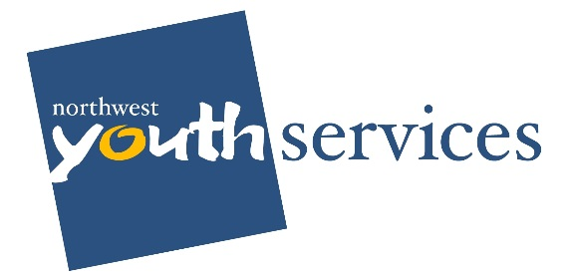
1020 North State Street
Bellingham, WA 98225
p. (360) 734-9862 f. (360) 734-4720
www.nwys.org
Help us grow a human being.

Greg Winter
1111 Cornwall Ave
Bellingham, WA 98225

Dear Greg Winter,
As you know, Northwest Youth Services has launched a search for our next executive director. We are working with Roam Consulting LLC, a Seattle-based consulting firm, with expertise in leadership transitions and executive search. Amanda Madorno, principal consultant, and Jill Sheldon, consulting associate, have completed 28 stakeholder interviews in order to identify the skills and experience, qualities and attributes, most needed in our next leader.
The culmination of this feedback informs the Position Profile, which we plan to approve at the January board meeting. Advertising and recruitment start in early February, selection and interviewing in March. Our goal is to have the new Executive Director on board in April 2019.
We’ve established an Executive Search Committee, currently comprised of three board members – myself, Lori Nichols and Hollie Brown. Because collaboration and partnership is so critical to the Executive’s success, we want to round out the Search Committee with two to four community members like yourself.
As a long-standing supporter and valued partner of Northwest Youth Services, we would be delighted and would greatly appreciate your leadership and expertise on the Search Committee. By participating, you have the opportunity to positively contribute to our efforts by utilizing your network and expertise to assist us in finding the best candidates. Your participation also ensures the community perspective on who and what we need in our next Executive during a pivotal time for the agency.

The Search Committee is charged with identifying, attracting, vetting and recommending a final candidate to the Board of Directors. With the support of our executive search consultants, we will use your time wisely and effectively.

The bulk of the Committee’s work occurs in March. We have scheduled three meetings which all Committee members must attend. We ask that you reserve the total block of time, even though we may finish early, depending on the number of potential candidates.

Semi-Finalist Review and Selection, March 20, 2019 12:00 pm – 5:00 pm.
- Review 7 to 10 potential semi-finalist candidates, presented by our search consultants
- Select 4 to 7 semi-finalists to interview.
- Provide feedback and insight into interview questions for semi-finalists.
- Determine selection criteria for evaluating candidates.

Semi-Finalist Interviews and Finalist Selection, March 27, 2019 from 11:00 am – 6:00 pm.
- Participate on the interview panel, provide insights into and ranking of candidates.
- Select 2 to 3 finalists.
- Provide feedback and insight into interview questions for finalists.
- Review plans and provide input for Finalist Day: meet and greet(s) and key guests, get-to-know-the-area activities, etc.

Finalist Day: April 10, 2019 from 8:00 am – 6:00 pm.
- Participate on the interview panel, provide insights into and ranking of candidates.
- As appropriate participate in other finalist day activities, e.g., introducing candidates to key people, attend meet and greet(s) and observe candidates, etc.
- Attend final session, incorporating feedback and observations from other stakeholders, and formulate hiring recommendation to Board of Directors.

We know that our executive search will only benefit from you insights and expertise. I hope that you will be able to accept and serve in this capacity.

Sincerely,

Ellie Posel
Board Chair and Chair of the Executive search Committee
Serving as Community Co-Chair
Enc: Search Committee Job Description, Search Timeline, Confidentiality Agreement (to be signed and returned to Roam consulting LLC).

