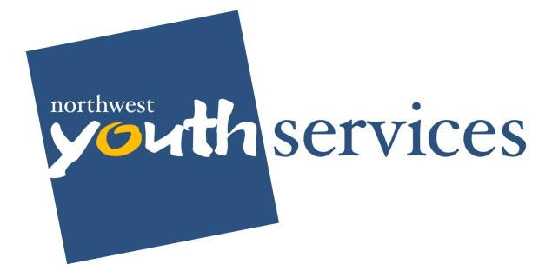
Program Acronyms
Program | Acronyms
Transitional Living Program | TL or TLP
Positive Adolescent Development Program | PAD or The PAD
Teen Court | TC
Homeless Student Stability Program | HSSP
Permanent Housing Program | Perm
Housing Under Served Low-Income Youth | HUSLY
Street Outreach Program | Detour or SOP
Queer Youth Project | QYP
Vocational Readiness Program | Voc
Whatcom | W-
Skagit | S-

Funding Source Acronyms & Cheat Sheet
Funding Source | Acronym | NWYS Program
Runaway and Homeless Youth Act (Federal) | RHYA or RHY | W-TLP  The PAD  Detour SOP
Bellingham Housing Levy Funds (City) | Levy | W-TLP  The PAD
Housing and Urban Development (Federal) | HUD | S-TLP
Substance Abuse and Mental Health Services Administration  (Federal) | SAMHSA | REVIVE – Behavioral Health Program
Consolidated Housing Grant (State Funds funneled through the County) | CHG | The PAD  W-Perm  Clinical Manager  S-TLP
United Way  (Foundation) | UW | W-TLP  S-TLP  The PAD
Emergency Food and Shelter Program  (Federal) | EFSP | The PAD
Northwest Children’s Fund (Foundation) | NWCF | The PAD
Department of Commerce  (State) | Commerce or DOC | The PAD (HOPE BEDS)  Behavioral Health Specialist  W-HUSLY  S-HUSLY  W-TLP  S-Perm  HSSP
City of Bellingham  (Federal and Local) | CoB | TC  W-Voc  The PAD  W-TLP
Office of Violence Against Women | OVW | SOP
Skagit Community Foundation | SKF | S-Voc

